A particle model for the gas state
1 This gas jar contains carbon dioxide at room temperature. It is in the gas state.
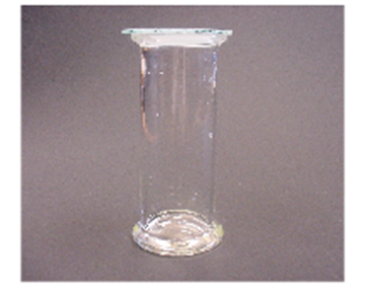
Which of A, B, C or D best describes it?
A It is made of particles which are ‘gassy’ – like tiny puffs of gas.
B There are particles dotted about in the carbon dioxide.
C It is made of particles which are not like little puffs of carbon dioxide.
D It does not have any particles.
2 Imagine you could see the particles in this sample of carbon dioxide.
Which diagram best matches what you would see?
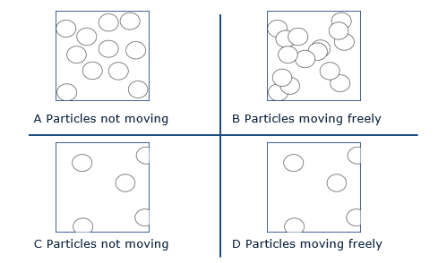

Chemistry > Big idea CPS: Particles and structure> Topic CPS1: Substances and mixturesl > Key concept CPS1.1: A particle model for the solid, liquid and gas states
Diagnostic question
A particle model for the gas state

Learning focus: | Understand a basic particle model of matter that can explain the properties of substances in the gas state.
Observable learning outcome: | Describe how the arrangement and movement of particles alters when a substance changes from the liquid to gas state.
Question type: | simple multiple choice
Key words: | gas, state, particles, volume

What does the research say?
Johnson and Papageorgiou (2010) suggest that the use of a ‘solids, liquids and gases’ framework for teaching may give rise to students misunderstanding the states of matter by inferring that solids, liquids and gases are three different types of matter. ‘Gases’ at room temperature are in fact substances where the forces of attraction between particles are very weak and therefore these forces are overcome, even at room temperature.
It should be noted that use of the term ‘attraction’ is inconsistent with later understanding of a chemical bond as a balance between attraction and repulsion. For this reason, Johnson suggests that alternative terminology, such as ‘ability to hold’ may be preferable.
Research has found that students often have a very weak understanding of what ‘a gas’ actually is. Evidence suggests that students may benefit from extrapolating the particle model to predict the arrangement and movement of particles that form a substance in the gas state. This particle model may then help students to think of ‘a gas’ as being a substance thereby improving their conceptual understanding of ‘a gas’. Linking the model to the arrangement and movement of particles forming a substance in the liquid states may also help students understand changes of state.
Ways to use this question
Students should complete the question individually. This could be a pencil and paper exercise, or you could use an electronic ‘voting system’ or mini white boards and the PowerPoint presentation.
The answers to the question will show you whether students understood the concept sufficiently well to apply it correctly.
You may also wish to use the diagnostic question ‘Empty space’ to check student understanding further.
Expected answers
1 C 1 D

How to respond - what next?
Question 1 addresses the relationship between particles and the substance and the nature of the particles themselves for the gas state. Appreciating that the macroscopic properties of the gas state are explained by the collective behaviour of the particles and not their individual ‘physical’ character is not easy (Option C). Option A may be selected by students who think that the particles are the substance but that the particles have macroscopic properties. Option B has extraneous particles, of unknown character, embedded in the continuous substance. Option D suggests that a student is still not thinking of a particle model.

Question 2 addresses intrinsic motion and spacing for the gas state. Options B and D are correct for the motion, but in B the particles are too close together (although one could argue about the pressure – the image of the jar only implies ‘normal’ pressure). However, some of these students may be thinking of particles being embedded in the continuous substance where the ‘gas’ would allow the unimpeded motion (unlike ‘swimming in ‘a liquid’ or being stuck ‘in a solid’). Few are likely to choose A or C.

If students have any misunderstandings about how the arrangement and movement of particles alters when a substance changes from the liquid to gas state encourage them to think about change that occur during melting, and then to consider what would happen next. The following BEST ‘response activity’ could be used in follow-up to this diagnostic question:
- Water in syringe
Acknowledgments
Developed by Helen Harden (UYSEG), from an idea by Andrew Hunt selected from a collection of ASK items devised for research by Philip Johnson (Durham University).

Images: ASK
References
Johnson, P. and Papageorgiou, G. (2010). Rethinking the Introduction of Particle Theory: A Substance-based framework. Journal of Research in Science Teaching. 42(2) 130-150
Johnson, P. (2012). Introducing particle theory. In Taber, K. (ed.) ASE Science Practice: Teaching Secondary Chemistry. New edition ed. London: Hodder Education.

